Practical - 5

Aim:
Implement a program of Counting Sort & analyse it.

Code:

#include <stdio.h>
#include <stdlib.h>

int count_countingSort = 0;
int count_maxElement = 0;

int maxElement(int arr[], int size) {
int max = arr[0];
for (int i = 1; i < size; i++) {
count_countingSort++;
if (arr[i] > max) {
max = arr[i];
}
}
count_maxElement = max;
return max;
}

int arrCopy(int source[], int dest[], int size) {
for (int i = 0; i < size; i++) {
dest[i] = source[i];
}
return 0;
}

int countingSort(int arr[], int size) {
int max = maxElement(arr, size);
// Create count array and initialize as 0
int count[max + 1];
for (int i = 0; i <= max; i++) {
count[i] = 0;
}

// Store count (Frequency) of each element
for (int i = 0; i < size; i++) {
count_countingSort++;
count[arr[i]]++;
}

// prefix sum of count array
for (int i = 1; i <= max; i++) {
count_countingSort++;
count[i] += count[i - 1];
}

// Build the output array
int ans[size];

// To make it stable we are running the loop from size-1 to 0
for (int i = size - 1; i >= 0; i--) {
count_countingSort++;
ans[count[arr[i]] - 1] = arr[i];
count[arr[i]]--;
}

// transfer the sorted elements back to original array
arrCopy(ans, arr, size);

return 0;
}

int main(){
FILE *fp = freopen("input.txt", "r", stdin);
int size;
scanf("%d", &size);
int *arr = malloc(size * sizeof(int));
for (int i = 0; i < size; i++) {
scanf("%d", &arr[i]);
}

countingSort(arr, size);

for (int i = 0; i < size; i++) {
printf("%d ", arr[i]);
}
printf("\nSize of input: %d", size);
printf("\nMax Element: %d", count_maxElement);
printf("\nCount: %d\n", count_countingSort);
return 0;
}

Output:
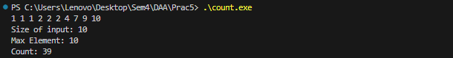
Analysis:
For Size 10:
Size of Input | Max Element | Steps In Sorting
10 | 10 | 39
100 | 10 | 309
250 | 10 | 759
500 | 10 | 1509
750 | 10 | 2259
1000 | 10 | 3009

For Size 100:
Size of Input | Max Element | Steps In Sorting
10 | 100 | 49
100 | 100 | 399
250 | 100 | 849
500 | 100 | 1599
750 | 100 | 2349
1000 | 100 | 3099

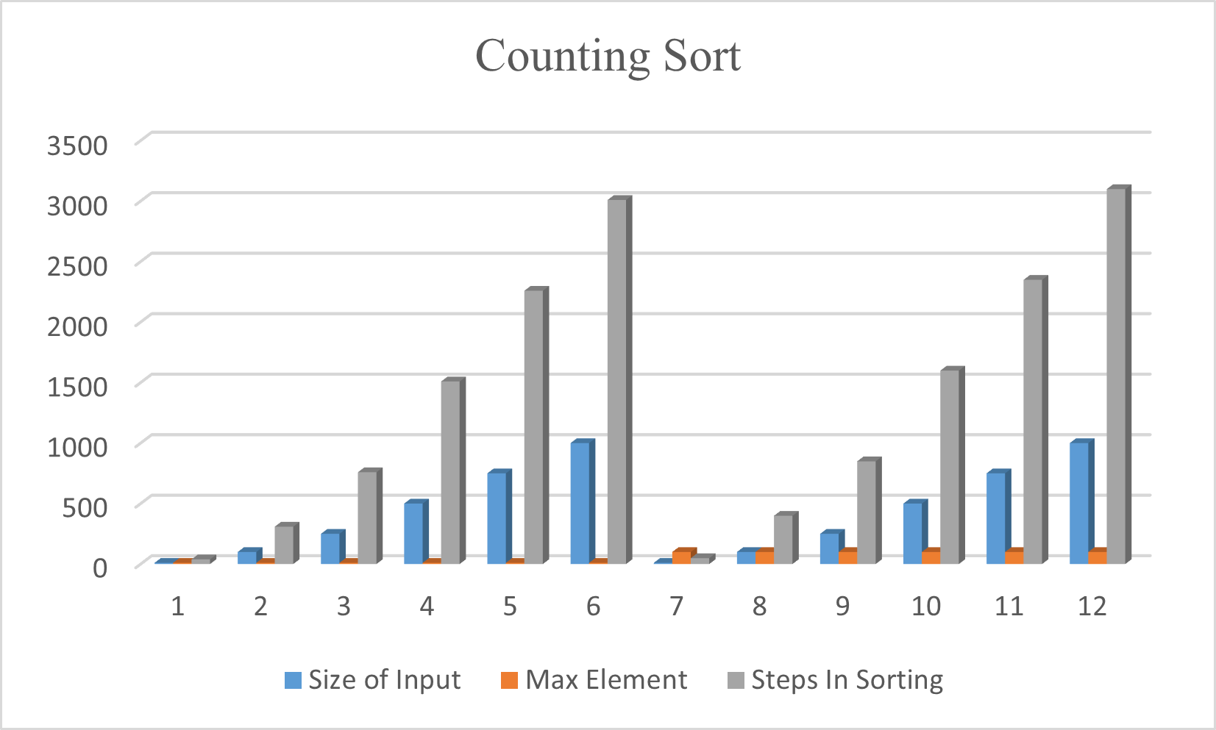
Conclusion:
- Best Use Case: It works best when the range of input values (𝑘) is not significantly larger than the number of elements (𝑛).
- Performance: It is a linear time algorithm, O(n+k), often used as a sub-routine in Radix Sort.
- Stability: It is a stable sort, meaning it maintains the relative order of equal elements, which is critical for specific applications.
- Limitations: It cannot be used for floating-point numbers and is memory-intensive for large ranges of input, as it requires O(k) auxiliary space.
- Summary: It is a specialized tool, offering superior speed for specific, constrained datasets.

